Altaev Alisher
Reflection Paper
January 10, 2024

The Globalization of Everything or How the “Big” Cultures Absorb the Small Ones?

Now, in 2022, Aiden from England and Mishuri from Japan wear the same shirt and watch the same movies. We still have the same borders around the world, but we can see that the invisible, cultural ones are getting erased. What is the main cause of that and what effect will it have in the near future? Further, I will talk about what is a “strong” culture, why and how we should save the “weak” ones. Firstly, we need to know what is the culture? McKelvie & Pappa (2021) define the culture as “the characteristics and knowledge of a particular group of people, encompassing language, religion, cuisine, social habits, music and arts.”. Basically, as we can see, culture is the habits and society's mentality, coming up to our days from the past. Bringing up the idea of the culture as the behavior and values of one group of people, which has been shaping over the centuries.

Nowadays, the rules of the game have changed. Now culture is not anything coming up from the past — it is the nets of connections. The reliable past becomes a “strong” culture, with its own nets and connections with others' past. Roman (nowadays South European culture) is the “strong” culture. Yet, we should look at the past and how it has survived through the ages and how the states of Ancient Europe became “Roman”. Caesar, the first Roman emperor, was very cruel outside of the Empire's borders (Maurois, 1973). He was treating gauls with harshness, destroying the cities and villages on his path. At the end of ten year’s war, we can see that millions of people were killed, but it has changed the appearance and the future of Europe forever. If Gaul had not been latinized, the Roman Empire would have become a weak Eastern country. Latinized Gallia tipped the scales in favor of the West. It is one of the examples of how the “strong” culture had spread in the past and how it destroyed a quantities of “weak” cultures, with its own writing system, music, literature, mythology and values.

However, now the strong culture is not spreading through the wars and crimes as in the past. It has a different structure and implementation to become globalized. To clarify the world’s main “strong” cultures, I have divided it into six main points.

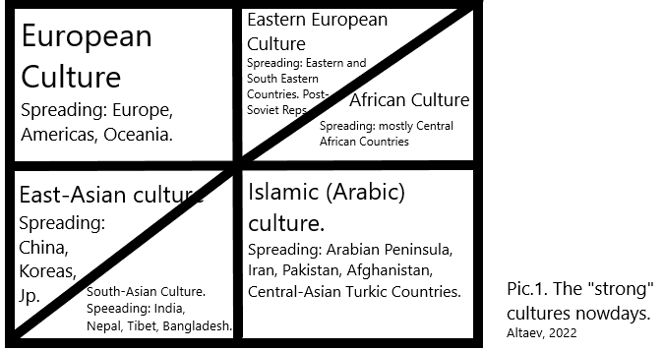

Pic.1. The main “strong” cultures nowadays.

Mostly all of these cultures were spread through the wars and colonialism, some strong cultures had a big impact on weak ones, so weak cultures were destroyed by themselves, accepting the changes more and more or were replaced. Let’s have one example: Islamic cultural spreading in the Central Asian region. Before Islam came, Central Asian tribes were worshipping Tengrianism (Tekin, 1993) and it was unmateralistic, the main value was harmony with universe (York, 2018). Yet, after Islamization Central Asian life changed a lot. Bukhara and Samarkand were the Islamic cultural and scientific centers, with a large amount of influencers, such as Al-Farabi and Al-Biruni, who are cited till our days. Nomads started to have its written language in Arabic written form and had a big philosophical effect from Peninsulian culture. The medieval nomad cities, such as Turkestan and Samarkand are popular because of their mosques, Islamic mosaic art and paintings. This is one of the examples, how the small, “weak” cultures had the impact of big ones. I would like to note that in that age there were at least ten main cultures. The six ones I have told before and also we had American-Indian, Egyptian (North-African), Central-Asian (Mongolian/Altaic) and Oceanic (Australian) cultures, but they were destroyed because of the wars, assimilation in big cultures and migrations.

As we move forward, the amount of “strong” cultures will be decreasing, because of the propaganda, informational wars and economic domination of some countries in the world area. Jiang’s (2013) theory of unipolarity, bipolarity and multipolarity cannot be ignored in that case. Empires, because of their ideology, always seek for the highest point of influence to the world. So, because of that, the world in its highest military development cannot be multipolar, it is always multi/or unipolar. Wohlforth (1999) argued that stability can be only in a unipolar world, because in a bipolar world (the Cold War between two superpowers: the capitalist USA and communist USSR) is unsafe for the world). However, nowadays it is unclear if our world is unipolar (US and Europe) or multipolar (USA, Europe, Russia and China). Michael Beckley argues that American primacy is underestimated, because it has a higher GDP per capita than India, China and other superpowers. Because of that the purchasing power as well as GDP are the main power for growing up the influence and spread it across the world. Weak cultures will be destroyed upon the American or Communist dream and ideology of industrialization or economical growth. So, as we can see, the military development and, especially, economical influence is the main cause of globalization nowadays: the growth of impact of a culture of an economically developed state.

It is necessary to say that culture is a tool to have influence and spread the ideology upon others: absorb the weak cultures. As Korean Pop became one of the main engine of ideological and economic progress in Korea due to its extreme popularity in the world (Barlett, 2022). So it can be the main cause of “cultural wars”. Only the nation and national awareness can save the culture. That is why some main cultures (Pic.1) should be aware and try to save the national ideology, mentality, and spread its own literature, music, language and movies.

We cannot say if it is bad or good to have a globalization of cultures across the world, it is the normal thing: evolutionary progress which cannot be avoided and took place from the Antique to our days, but we can only save our own cultures by consuming it on an everyday basis. Be a consumer of your culture, spread it across the world: do not try to stop globalization, try to make your culture a globalization cause.

References:

Bartlett, J. (2022, June 28). Domestic and global political impacts of K-pop: Boa, BTS, and beyond. The Diplomat. Retrieved September 21, 2022, from https://thediplomat.com/2022/06/domestic-and-global-political-impacts-of-k-pop-boa-bts-and-beyond/#:~:text=As%20a%20result%2C%20Korean%20pop,pop%20culture%20roughly%20doubled%20from
Beckley, M. (2018). The Power of Nations: Measuring what matters. International Security, 43(2), 7–44. https://doi.org/10.1162/isec_a_00328
Deutsch, K. W., & Singer, J. D. (1964). In Multipolar Power Systems and international stability (pp. 390–406). essay, Yale University, Political Science Research Library.
Deutsch, K. W., & Singer, J. D. (1964). Multipolar Power Systems and international stability. World Politics, 16(3). https://doi.org/10.2307/2009578
Jiang, S (2013). Is Bipolarity a sound recipe for world order–as compared to other historically known alternatives. In ICD Annual Conference on Cultural Diplomacy in the USA Options on the Table. Old Dominion University.
Maurois, A. (1973). History of France. Funk & Wagnalls Co.
McKelvie, C., & Pappas, S. (2021, December 15). What is culture? LiveScience. Retrieved September 21, 2022, from https://www.livescience.com/21478-what-is-culture-definition-of-culture.html
Tekin Talât. (1993). Irk bitig: The book of omens. Harrassowitz.
Wohlforth, W. C. (1999). The stability of a Unipolar World. International Security, 24(1), 5–41. https://doi.org/10.1162/016228899560031
York, M. (2018). Pagan mysticism: Paganism as a world religion. by MichaelYork. Newcastle upon Tyne, UK: Cambridge Scholars Publishing, 2019. pp. XI + 337. Hardback, £64.99. Religious Studies Review, 45(3). https://doi.org/10.1111/rsr.14243

